CO4 — AT3
Comparative Analysis
Object Detection, Motion Estimation & Depth Estimation — Worked Solutions
Course Outcome: CO4 — Computer Vision & Object Detection Systems
Prepared with worked calculations, comparative tables, and supporting charts.

Question 1. Object Detection Performance Comparison
Model A (Viola–Jones): TP = 80, FP = 20, FN = 30 Model B (YOLO): TP = 90, FP = 15, FN = 20
(a) Precision and Recall
Precision = TP / (TP + FP) Recall = TP / (TP + FN)
Model A:
Precision = 80 / (80 + 20) = 80 / 100 = 0.80 → 80.0%
Recall = 80 / (80 + 30) = 80 / 110 = 0.727 → 72.7%
Model B:
Precision = 90 / (90 + 15) = 90 / 105 = 0.857 → 85.7%
Recall = 90 / (90 + 20) = 90 / 110 = 0.818 → 81.8%
Model | TP | FP | FN | Precision | Recall
Model A — Viola–Jones | 80 | 20 | 30 | 80.0% | 72.7%
Model B — YOLO | 90 | 15 | 20 | 85.7% | 81.8%
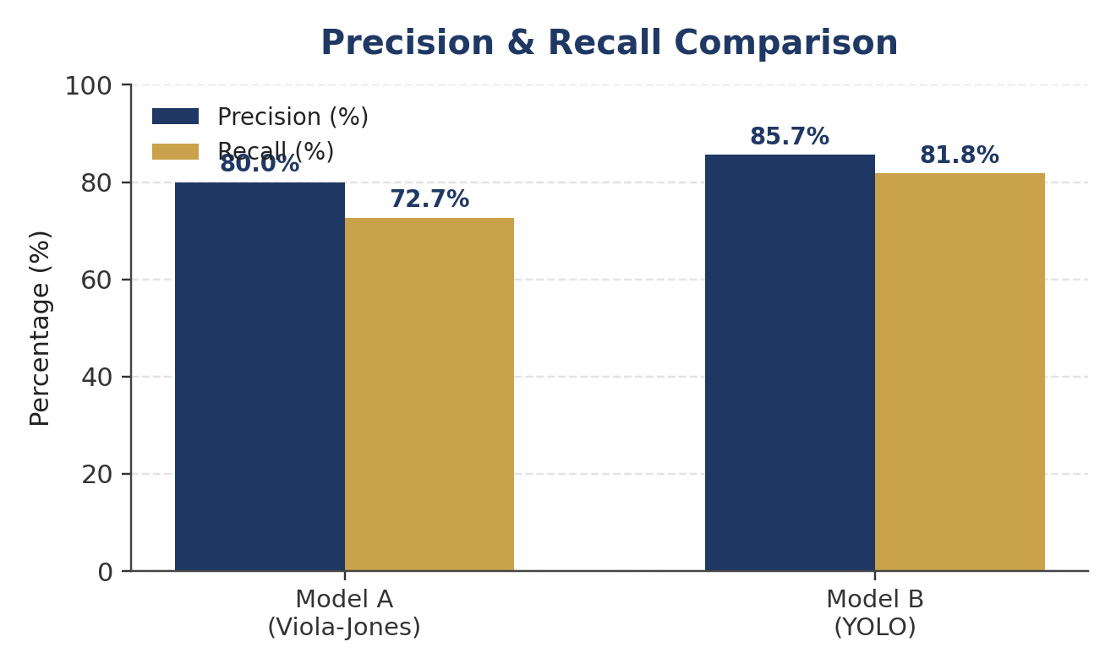
Figure 1.1 — Precision and Recall comparison of Model A and Model B.
(b) Comparison & Justification
Model B (YOLO) outperforms Model A (Viola–Jones) on both metrics: precision is higher by 5.7 percentage points (85.7% vs 80.0%) and recall is higher by 9.1 percentage points (81.8% vs 72.7%). A higher precision means Model B produces proportionally fewer false alarms, while a higher recall means it misses fewer actual objects. Since Model B dominates on both axes simultaneously (there is no trade-off where Model A wins on one metric), it provides the better overall object detection performance.
✔ Conclusion: Model B (YOLO) is the better-performing model — it achieves both higher precision and higher recall than Model A.

Question 2. Motion Estimation Error Analysis
Method A displacement errors (pixels): 2, 3, 2 Method B displacement errors (pixels): 3, 5, 4
(a) Average Displacement Error
Average Error = (Error₁ + Error₂ + Error₃) / 3
Method A:
Average = (2 + 3 + 2) / 3 = 7 / 3 = 2.33 pixels
Method B:
Average = (3 + 5 + 4) / 3 = 12 / 3 = 4.00 pixels
Method | Frame 1 | Frame 2 | Frame 3 | Average Error (px)
Method A | 2 | 3 | 2 | 2.33
Method B | 3 | 5 | 4 | 4.00
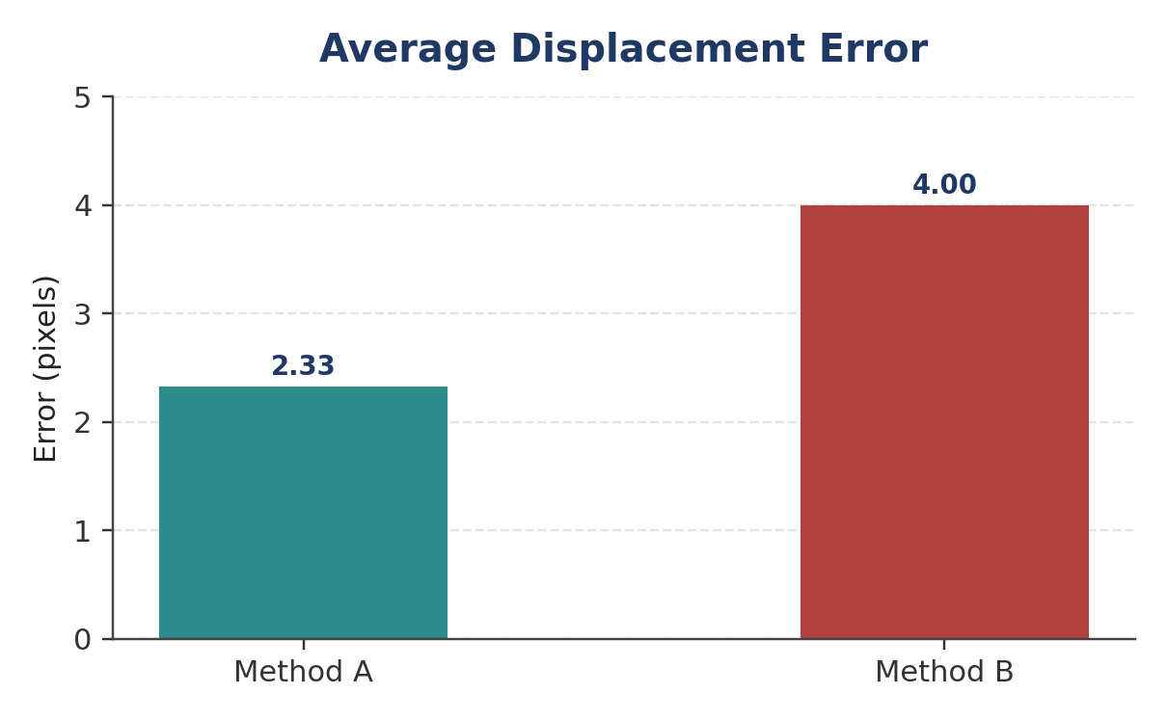
Figure 2.1 — Average displacement error per method (lower is better).
(b) & (c) Comparison and Justification
Method A produces a lower average displacement error (2.33 px) than Method B (4.00 px) — a reduction of about 42%. Since displacement error directly measures how far the estimated motion vector deviates from the true motion, a lower value indicates the estimated positions are consistently closer to the actual displacement across all three frames (Method A: 2, 3, 2 vs Method B: 3, 5, 4 — Method A is lower in every single frame, not just on average).
✔ Conclusion: Method A provides more accurate motion estimation, as it consistently yields a lower displacement error in every frame and a lower overall average.

Question 3. Depth Estimation Comparison
Actual depths: 2 m, 3 m, 4 m Stereo Vision: 2.0 m, 3.0 m, 4.0 m SfM: 2.5 m, 3.8 m, 5.0 m
(a) Absolute Error per Object
Absolute Error = | Estimated Depth − Actual Depth |
Object | Actual (m) | Stereo Est. (m) | Stereo |Error| (m) | SfM Est. (m) | SfM |Error| (m)
Object 1 | 2.0 | 2.0 | 0.0 | 2.5 | 0.5
Object 2 | 3.0 | 3.0 | 0.0 | 3.8 | 0.8
Object 3 | 4.0 | 4.0 | 0.0 | 5.0 | 1.0
(b) Average Absolute Error
Stereo Vision: (0.0 + 0.0 + 0.0) / 3 = 0.0 m
SfM: (0.5 + 0.8 + 1.0) / 3 = 2.3 / 3 = 0.767 m
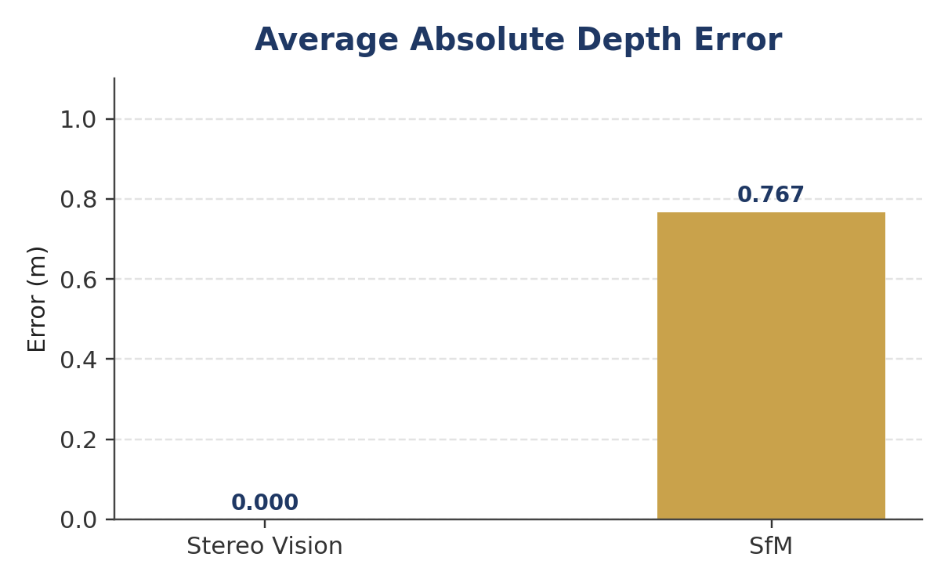
Figure 3.1 — Average absolute depth error: Stereo Vision vs Structure-from-Motion.
(c) Comparison & Justification
Stereo Vision estimates match the actual depths exactly for all three objects (0.0 m average absolute error), whereas SfM shows an increasing error as depth grows (0.5 m, 0.8 m, 1.0 m), giving an average absolute error of 0.767 m. This growing error pattern is typical of monocular SfM, whose depth estimates rely on triangulation across estimated camera motion and tend to drift with scene depth and scale ambiguity, while calibrated Stereo Vision uses a fixed, known baseline that yields more geometrically consistent results.
✔ Conclusion: Stereo Vision provides more accurate depth estimation, with zero average absolute error compared to SfM's 0.767 m.

